import pandas as pd
import numpy as np
data = pd.read_csv("Amazon Sales data.csv")
data.head()
Region Country Item Type \
0 Australia and Oceania Tuvalu Baby Food
1 Central America and the Caribbean Grenada Cereal
2 Europe Russia Office Supplies
3 Sub-Saharan Africa Sao Tome and Principe Fruits
4 Sub-Saharan Africa Rwanda Office Supplies
Sales Channel Order Priority Order Date Order ID Ship Date Units Sold \
0 Offline H 5/28/2010 669165933 6/27/2010 9925
1 Online C 8/22/2012 963881480 9/15/2012 2804
2 Offline L 5/2/2014 341417157 5/8/2014 1779
3 Online C 6/20/2014 514321792 7/5/2014 8102
4 Offline L 2/1/2013 115456712 2/6/2013 5062
Unit Price Unit Cost Total Revenue Total Cost Total Profit
0 255.28 159.42 2533654.00 1582243.50 951410.50
1 205.70 117.11 576782.80 328376.44 248406.36
2 651.21 524.96 1158502.59 933903.84 224598.75
3 9.33 6.92 75591.66 56065.84 19525.82
4 651.21 524.96 3296425.02 2657347.52 639077.50
data.tail()
Region Country Item Type Sales Channel \
95 Sub-Saharan Africa Mali Clothes Online
96 Asia Malaysia Fruits Offline
97 Sub-Saharan Africa Sierra Leone Vegetables Offline
98 North America Mexico Personal Care Offline
99 Sub-Saharan Africa Mozambique Household Offline
Order Priority Order Date Order ID Ship Date Units Sold Unit Price \
95 M 7/26/2011 512878119 9/3/2011 888 109.28
96 L 11/11/2011 810711038 12/28/2011 6267 9.33
97 C 6/1/2016 728815257 6/29/2016 1485 154.06
98 M 7/30/2015 559427106 8/8/2015 5767 81.73
99 L 2/10/2012 665095412 2/15/2012 5367 668.27
Unit Cost Total Revenue Total Cost Total Profit
95 35.84 97040.64 31825.92 65214.72
96 6.92 58471.11 43367.64 15103.47
97 90.93 228779.10 135031.05 93748.05
98 56.67 471336.91 326815.89 144521.02
99 502.54 3586605.09 2697132.18 889472.91
data.describe()
Order ID Units Sold Unit Price Unit Cost Total Revenue \
count 1.000000e+02 100.000000 100.000000 100.000000 1.000000e+02
mean 5.550204e+08 5128.710000 276.761300 191.048000 1.373488e+06
std 2.606153e+08 2794.484562 235.592241 188.208181 1.460029e+06
min 1.146066e+08 124.000000 9.330000 6.920000 4.870260e+03
25% 3.389225e+08 2836.250000 81.730000 35.840000 2.687212e+05
50% 5.577086e+08 5382.500000 179.880000 107.275000 7.523144e+05
75% 7.907551e+08 7369.000000 437.200000 263.330000 2.212045e+06
max 9.940222e+08 9925.000000 668.270000 524.960000 5.997055e+06
Total Cost Total Profit
count 1.000000e+02 1.000000e+02
mean 9.318057e+05 4.416820e+05
std 1.083938e+06 4.385379e+05
min 3.612240e+03 1.258020e+03
25% 1.688680e+05 1.214436e+05
50% 3.635664e+05 2.907680e+05
75% 1.613870e+06 6.358288e+05
max 4.509794e+06 1.719922e+06
data.isnull().sum()
Region 0
Country 0
Item Type 0
Sales Channel 0
Order Priority 0
Order Date 0
Order ID 0
Ship Date 0
Units Sold 0
Unit Price 0
Unit Cost 0
Total Revenue 0
Total Cost 0
Total Profit 0
dtype: int64
data[data.duplicated()]
Empty DataFrame
Columns: [Region, Country, Item Type, Sales Channel, Order Priority, Order Date, Order ID, Ship Date, Units Sold, Unit Price, Unit Cost, Total Revenue, Total Cost, Total Profit]
Index: []
data.info()
<class 'pandas.core.frame.DataFrame'>
RangeIndex: 100 entries, 0 to 99
Data columns (total 14 columns):
# Column Non-Null Count Dtype
--- ------ -------------- -----
0 Region 100 non-null object
1 Country 100 non-null object
2 Item Type 100 non-null object
3 Sales Channel 100 non-null object
4 Order Priority 100 non-null object
5 Order Date 100 non-null object
6 Order ID 100 non-null int64
7 Ship Date 100 non-null object
8 Units Sold 100 non-null int64
9 Unit Price 100 non-null float64
10 Unit Cost 100 non-null float64
11 Total Revenue 100 non-null float64
12 Total Cost 100 non-null float64
13 Total Profit 100 non-null float64
dtypes: float64(5), int64(2), object(7)
memory usage: 11.1+ KB
data.columns
Index(['Region', 'Country', 'Item Type', 'Sales Channel', 'Order Priority',
'Order Date', 'Order ID', 'Ship Date', 'Units Sold', 'Unit Price',
'Unit Cost', 'Total Revenue', 'Total Cost', 'Total Profit'],
dtype='object')
# Convert date columns to datetime data type
data['Order Date'] = pd.to_datetime(data['Order Date'], errors='coerce')
data['Ship Date'] = pd.to_datetime(data['Ship Date'], errors='coerce')
data.head()
Region Country Item Type \
0 Australia and Oceania Tuvalu Baby Food
1 Central America and the Caribbean Grenada Cereal
2 Europe Russia Office Supplies
3 Sub-Saharan Africa Sao Tome and Principe Fruits
4 Sub-Saharan Africa Rwanda Office Supplies
Sales Channel Order Priority Order Date Order ID Ship Date Units Sold \
0 Offline H 2010-05-28 669165933 2010-06-27 9925
1 Online C 2012-08-22 963881480 2012-09-15 2804
2 Offline L 2014-05-02 341417157 2014-05-08 1779
3 Online C 2014-06-20 514321792 2014-07-05 8102
4 Offline L 2013-02-01 115456712 2013-02-06 5062
Unit Price Unit Cost Total Revenue Total Cost Total Profit
0 255.28 159.42 2533654.00 1582243.50 951410.50
1 205.70 117.11 576782.80 328376.44 248406.36
2 651.21 524.96 1158502.59 933903.84 224598.75
3 9.33 6.92 75591.66 56065.84 19525.82
4 651.21 524.96 3296425.02 2657347.52 639077.50
# Extract month and year from 'Order Date' column
data['Order Month'] = data['Order Date'].dt.month
data['Order Year'] = data['Order Date'].dt.year
# Calculate total sales
data['Total Sales'] = data['Total Revenue']
data.head()
Region Country Item Type \
0 Australia and Oceania Tuvalu Baby Food
1 Central America and the Caribbean Grenada Cereal
2 Europe Russia Office Supplies
3 Sub-Saharan Africa Sao Tome and Principe Fruits
4 Sub-Saharan Africa Rwanda Office Supplies
Sales Channel Order Priority Order Date Order ID Ship Date Units Sold \
0 Offline H 2010-05-28 669165933 2010-06-27 9925
1 Online C 2012-08-22 963881480 2012-09-15 2804
2 Offline L 2014-05-02 341417157 2014-05-08 1779
3 Online C 2014-06-20 514321792 2014-07-05 8102
4 Offline L 2013-02-01 115456712 2013-02-06 5062
Unit Price Unit Cost Total Revenue Total Cost Total Profit \
0 255.28 159.42 2533654.00 1582243.50 951410.50
1 205.70 117.11 576782.80 328376.44 248406.36
2 651.21 524.96 1158502.59 933903.84 224598.75
3 9.33 6.92 75591.66 56065.84 19525.82
4 651.21 524.96 3296425.02 2657347.52 639077.50
Order Month Order Year Total Sales
0 5 2010 2533654.00
1 8 2012 576782.80
2 5 2014 1158502.59
3 6 2014 75591.66
4 2 2013 3296425.02
month_wise_sales = data.groupby('Order Month')['Total Sales'].sum()
print(month_wise_sales)
Order Month
1 10482467.12
2 24740517.77
3 2274823.87
4 16187186.33
5 13215739.99
6 5230325.77
7 15669518.50
8 1128164.91
9 5314762.56
10 15287576.61
11 20568222.76
12 7249462.12
Name: Total Sales, dtype: float64
year_wise_sales = data.groupby('Order Year')['Total Sales'].sum()
print(year_wise_sales)
Order Year
2010 19186024.92
2011 11129166.07
2012 31898644.52
2013 20330448.66
2014 16630214.43
2015 12427982.86
2016 12372867.22
2017 13373419.63
Name: Total Sales, dtype: float64
year_wise_sales = data.groupby('Order Year')['Total Sales'].sum()
print(year_wise_sales)
Order Year
2010 19186024.92
2011 11129166.07
2012 31898644.52
2013 20330448.66
2014 16630214.43
2015 12427982.86
2016 12372867.22
2017 13373419.63
Name: Total Sales, dtype: float64
year_wise_month_wise_sales = data.groupby(['Order Year', 'Order Month'])['Total Sales'].sum()
year_wise_month_wise_sales
Order Year Order Month
2010 2 3410661.12
5 2587973.26
6 1082418.40
10 6064933.75
11 3458252.00
12 2581786.39
2011 1 1042225.35
2 387002.20
4 2798046.49
5 272410.45
6 19103.44
7 97040.64
9 574951.92
11 5938385.58
2012 1 1012884.00
2 6707849.42
3 994765.42
4 4556012.38
5 3782781.82
6 2132075.27
7 4445093.92
8 576782.80
9 4648152.72
10 3042246.77
2013 2 3296425.02
3 835759.10
4 3262562.10
6 1352867.40
7 8545511.20
8 89623.98
9 71253.21
10 2702770.40
12 173676.25
2014 2 1819660.25
4 4510578.10
5 3060338.59
6 75591.66
7 688641.85
8 455479.04
9 20404.71
10 1352370.65
11 4647149.58
2015 1 5513227.50
2 2003911.12
4 1059987.26
7 1292409.45
8 6279.09
10 1904138.04
11 648030.40
2016 3 197883.40
5 414371.10
6 568269.60
7 600821.44
10 221117.00
11 5876405.20
12 4493999.48
2017 1 2914130.27
2 7115008.64
3 246415.95
5 3097864.77
Name: Total Sales, dtype: float64

Total sales
total_sales = data['Total Sales'].sum()
print("Total Sales:", total_sales)
Total Sales: 137348768.31

Total Profit
total_profit = data['Total Profit'].sum()
print("Total Profit:", total_profit)
Total Profit: 44168198.39999999

Average Unit Price
average_unit_price = data['Unit Price'].mean()
print("Average Unit Price:", average_unit_price)
Average Unit Price: 276.76130000000006

Relationship between Atributes
# Scatter Plot between Total revenue and total profit
import matplotlib.pyplot as plt
plt.scatter(data['Total Revenue'],data['Total Profit'])
plt.xlabel('Total Revenue')
plt.ylabel('Total Profit')
plt.title('Scatter Plot: Total Revenue vs Total Profit')
plt.show()
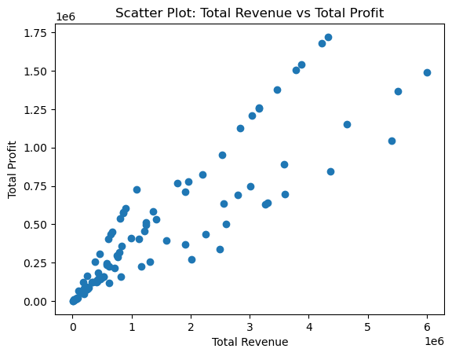
#Heatnakjp of Correlation Matrix
import seaborn as sns
correlation_matrix = data.corr()
plt.figure(figsize=(10,8))
sns.heatmap(correlation_matrix, annot=True, cmap='coolwarm', fmt=".2f")
plt.title('Correlation Matrix')
plt.show()
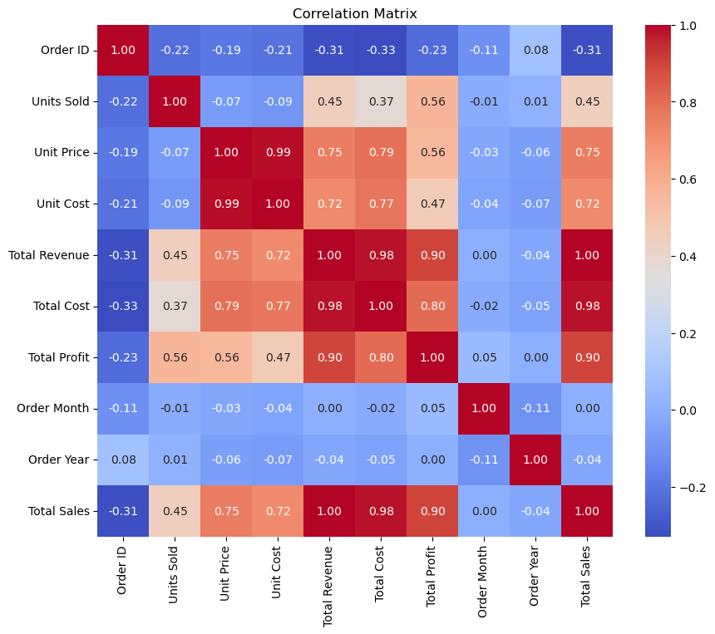
#Box Plot of Total Sales by Sales Channel
plt.figure(figsize=(8, 6))
sns.boxplot(x='Sales Channel', y='Total Sales', data=data)
plt.xlabel('Sales Channel')
plt.ylabel('Total Sales')
plt.title('Box Plot: Total Sales by Sales Channel')
plt.show()
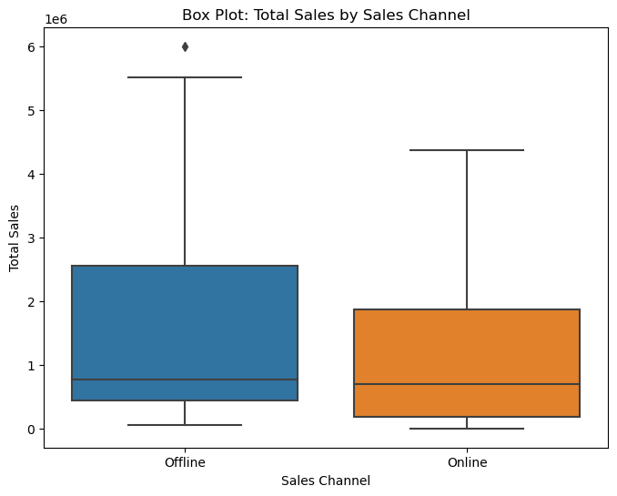
#Line Plot of Monthly Total Sales over the Years
monthly_sales_yearwise = data.groupby(['Order Year', 'Order Month'])['Total Sales'].sum().reset_index()
plt.figure(figsize=(10, 6))
sns.lineplot(x='Order Month', y='Total Sales', hue='Order Year', data=monthly_sales_yearwise)
plt.xlabel('Month')
plt.ylabel('Total Sales')
plt.title('Monthly Total Sales Over the Years')
plt.legend(title='Year')
plt.show()
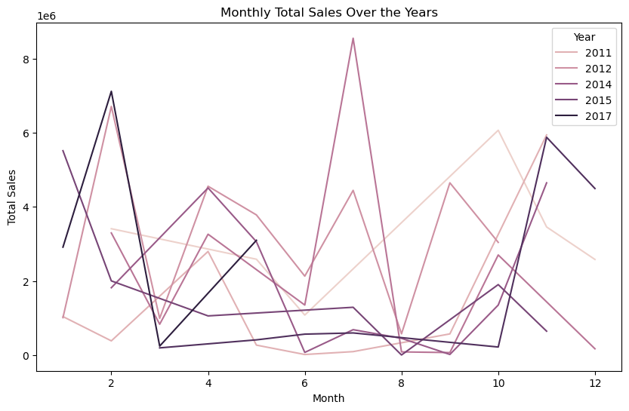
#Distribution of Unit Price
plt.figure(figsize=(8, 6))
sns.histplot(data['Unit Price'], kde=True)
plt.xlabel('Unit Price')
plt.ylabel('Frequency')
plt.title('Distribution of Unit Price')
plt.show()
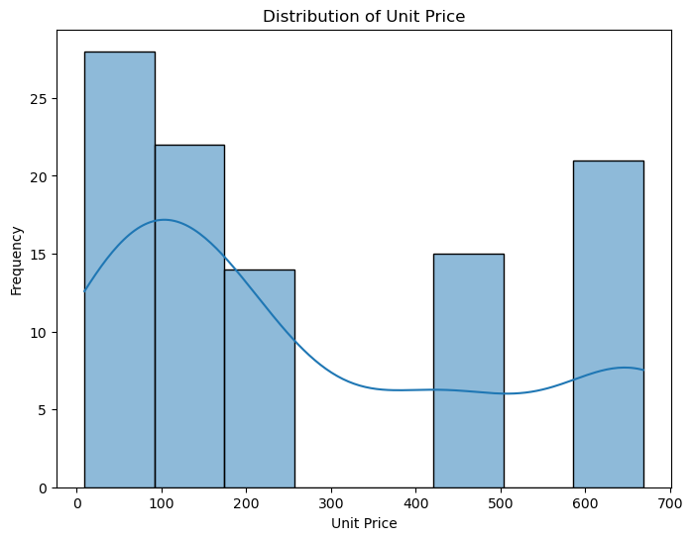
sns.pairplot(data)
plt.title('Pairplot of Numerical Variables')
plt.show()
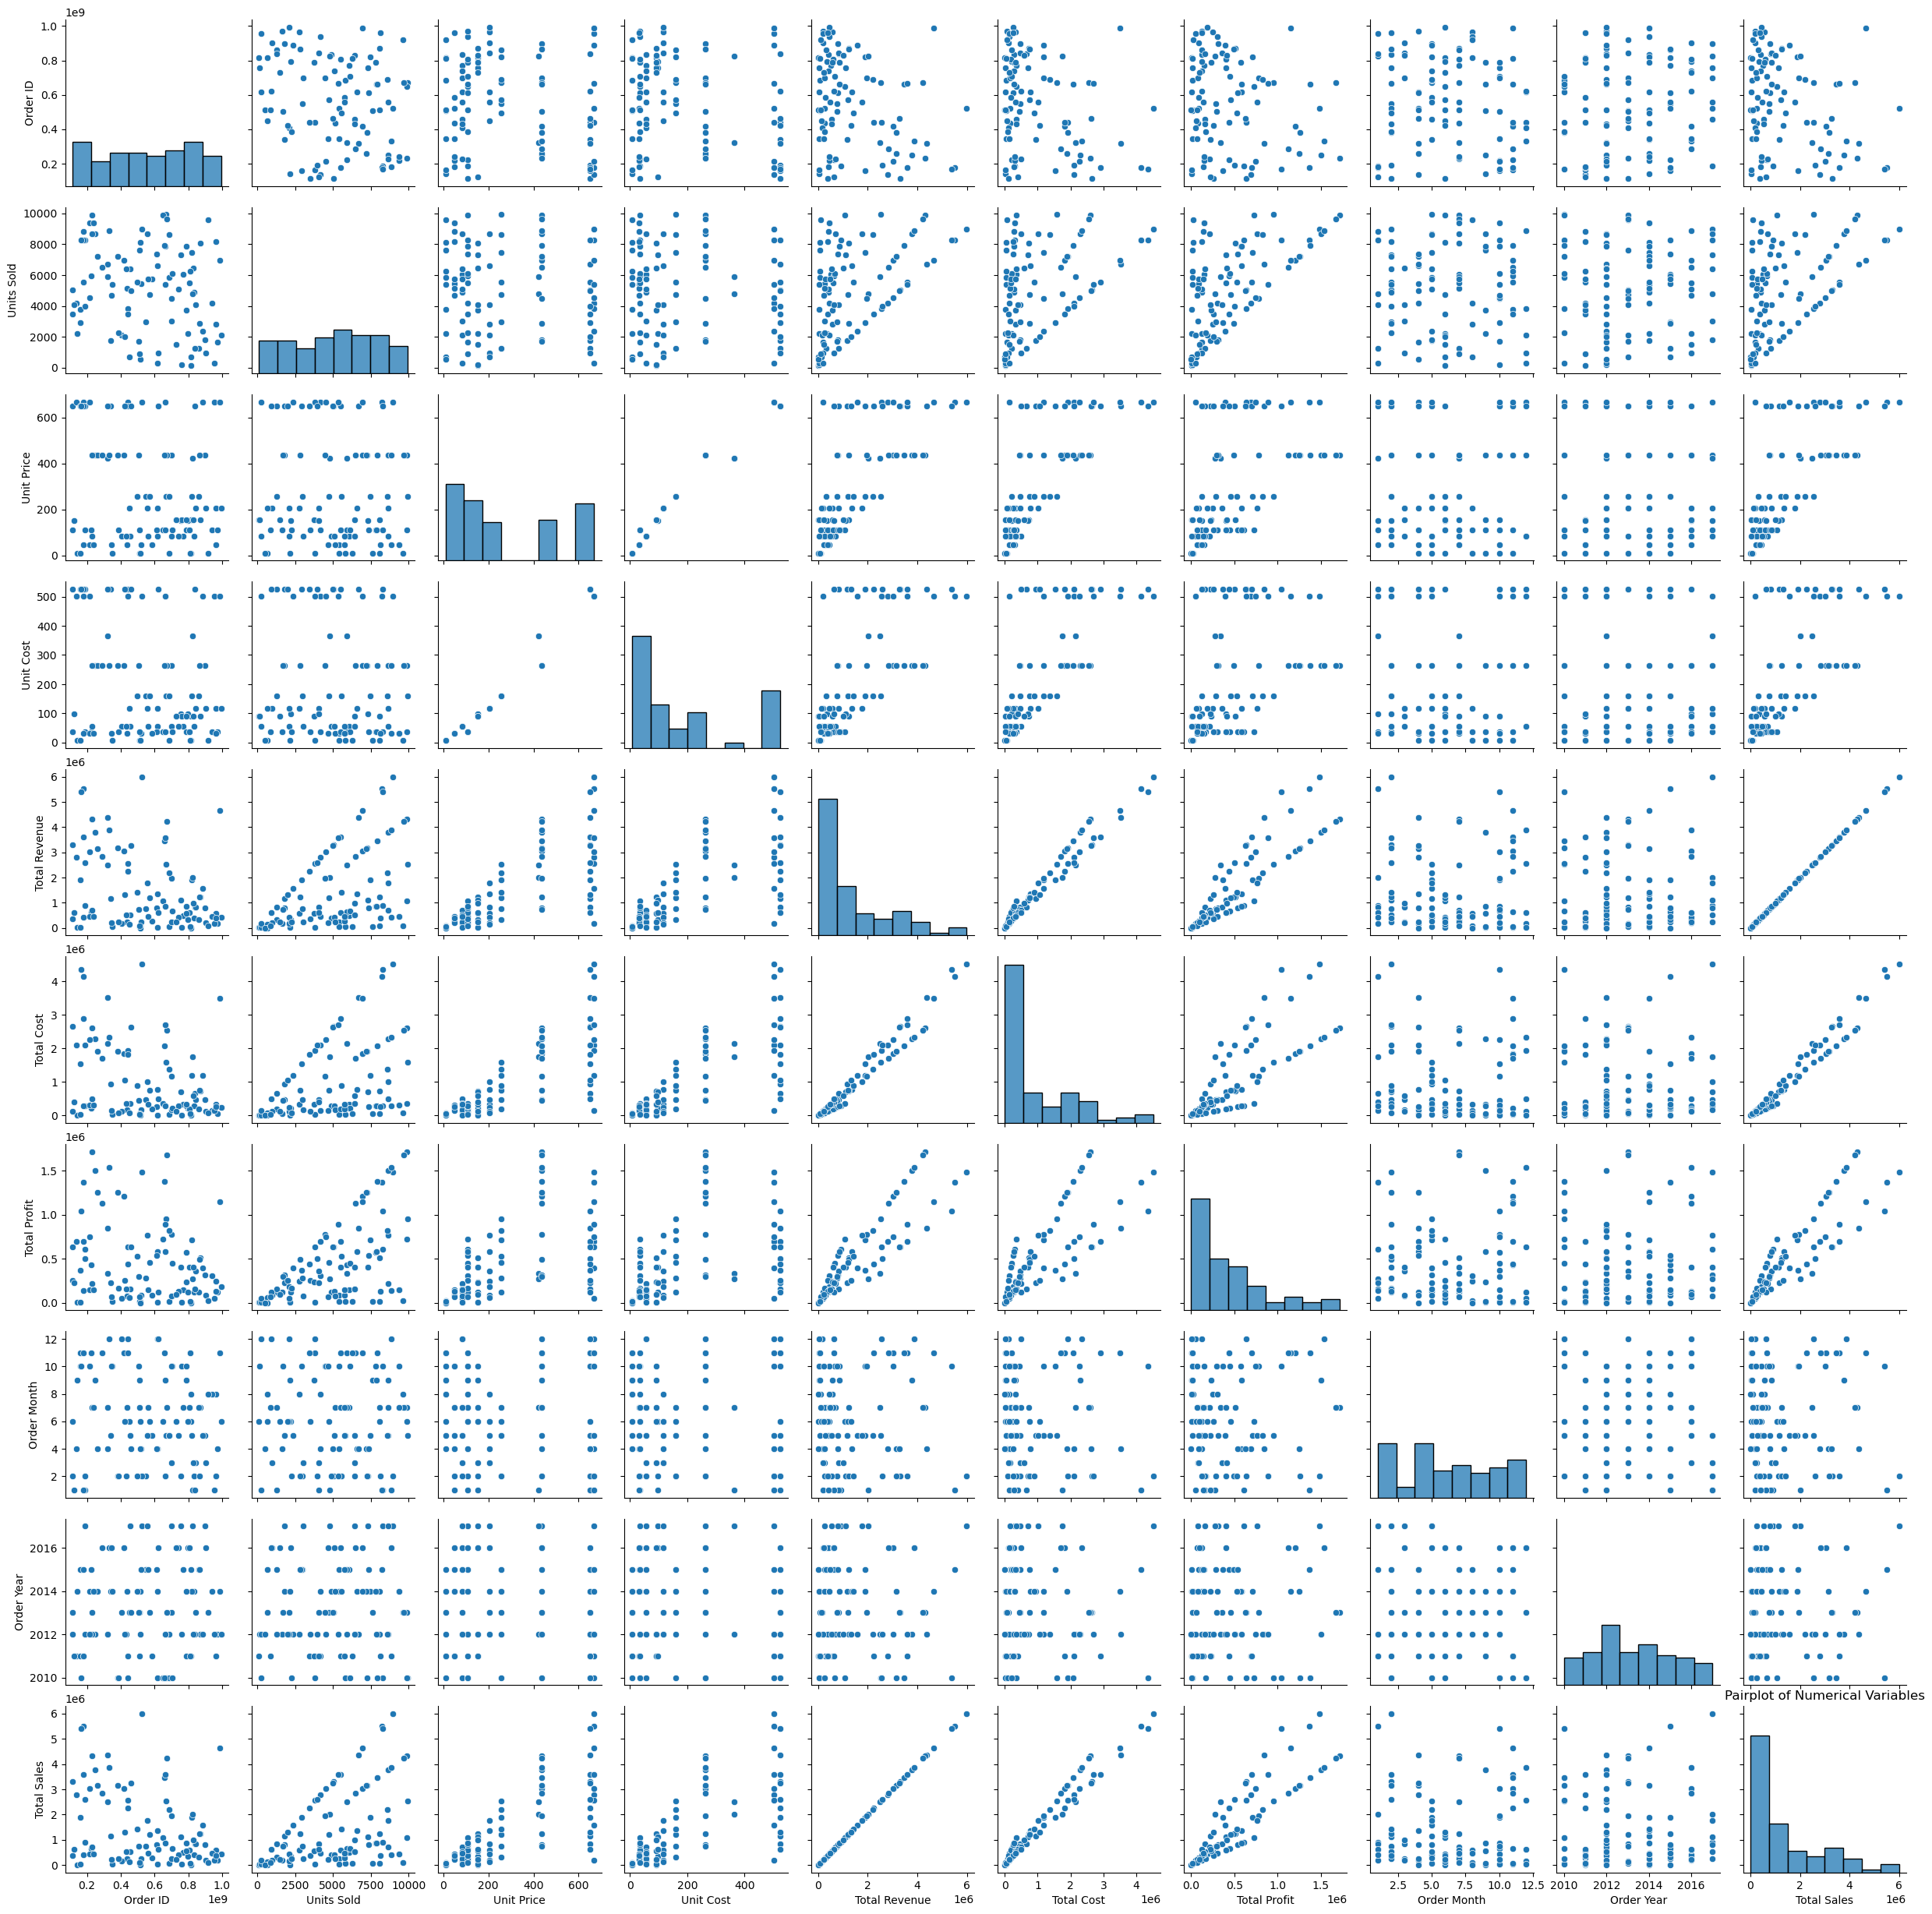
#Bar Plot of Total Sales by Region
plt.figure(figsize=(10, 6))
sns.barplot(x='Region', y='Total Sales', data=data)
plt.xlabel('Region')
plt.ylabel('Total Sales')
plt.title('Bar Plot: Total Sales by Region')
plt.xticks(rotation=45)
plt.show()
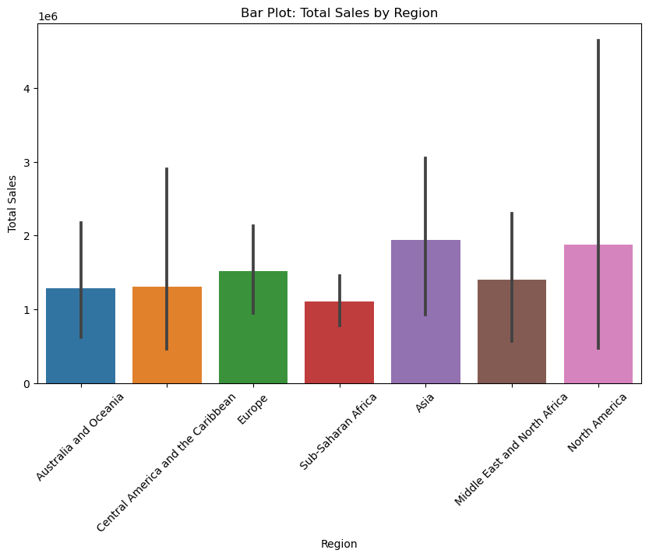
#Violin Plot of Total Profit by Order Priority
plt.figure(figsize=(8, 6))
sns.violinplot(x='Order Priority', y='Total Profit', data=data)
plt.xlabel('Order Priority')
plt.ylabel('Total Profit')
plt.title('Violin Plot: Total Profit by Order Priority')
plt.show()
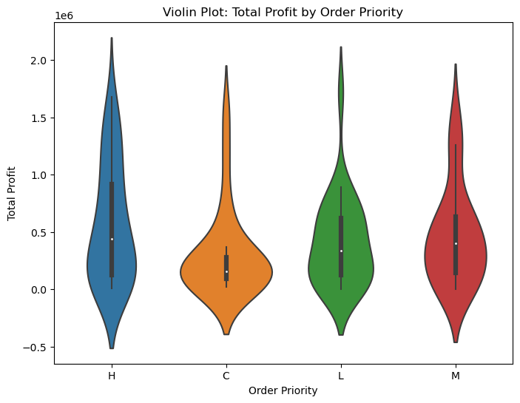

1. Sales Trends:

- Monthly total sales fluctuate over the years, with certain months showing higher sales volumes.

- Yearly total sales generally show an increasing trend, indicating overall growth in sales over time.

2.Factors Impacting Sales:

- Sales channel seems to have a significant impact on total sales, with offline sales channels generally showing higher variability.

- Region also plays a crucial role, with some regions consistently performing better in terms of total sales compared to others.

3. Profitability:

- There's a positive correlation between total revenue and total profit, indicating that higher revenue tends to lead to higher profits.

- Order priority does not seem to have a significant impact on total profit based on the violin plot.

4. Price Distribution:

- The distribution of unit prices is skewed, with most items falling within a certain price range but some outliers having significantly higher prices.

5. Performance Across Categories:

- Certain product categories, such as cosmetics and office supplies, tend to contribute more to total revenue and profit compared to others.

6. Sales Channel Comparison:

- Online sales channels appear to have more consistent performance compared to offline channels, as indicated by the box plot of total sales by sales channel.

Overall, the analysis highlights the importance of considering factors such as sales channel, region, and product category when devising sales strategies and making business decisions to optimize revenue and profitability.
# 1 Time Series Analysis:
# - We can perform time series analysis on monthly total sales data to identify any seasonal patterns or trends over time.
# - Techniques like decomposition can help us separate the trend, seasonality, and residual components of the sales data.
# Convert 'Order Date' to datetime format
data['Order Date'] = pd.to_datetime(data['Order Date'])
# Extract month and year from 'Order Date'
data['Month'] = data['Order Date'].dt.month
data['Year'] = data['Order Date'].dt.year
# Monthly total sales
monthly_sales = data.groupby(['Year', 'Month'])['Total Sales'].sum().reset_index()
# Time series plot of monthly total sales
plt.figure(figsize=(10, 6))
sns.lineplot(x='Month', y='Total Sales', hue='Year', data=monthly_sales)
plt.title('Time Series Plot of Monthly Total Sales')
plt.xlabel('Month')
plt.ylabel('Total Sales')
plt.legend(title='Year', loc='upper right')
plt.xticks(np.arange(1, 13, 1))
plt.grid(True)
plt.show()
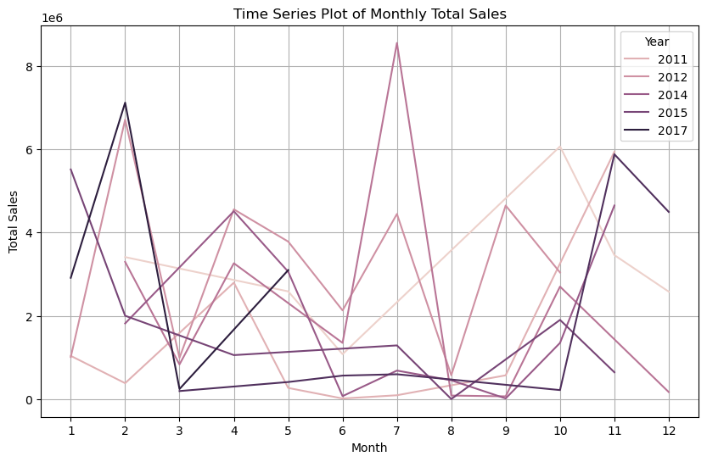
# 2 Regression Analysis:
# - We can conduct regression analysis to quantify the relationships between various factors (such as sales channel, region, order priority) and total sales or total profit.
# - This can help us determine the significance of each factor and understand how much they contribute to overall sales or profit.
# Perform regression analysis to predict total sales
from sklearn.linear_model import LinearRegression
from sklearn.model_selection import train_test_split
from sklearn.metrics import mean_squared_error
# Prepare data for regression
X = data[['Units Sold', 'Unit Price', 'Unit Cost']]
y = data['Total Sales']
# Split data into training and testing sets
X_train, X_test, y_train, y_test = train_test_split(X, y, test_size=0.2, random_state=42)
# Initialize and fit linear regression model
reg_model = LinearRegression()
reg_model.fit(X_train, y_train)
LinearRegression()
# Predict total sales
y_pred = reg_model.predict(X_test)
# Calculate Mean Squared Error
mse = mean_squared_error(y_test, y_pred)
print('Mean Squared Error:', mse)
Mean Squared Error: 322510611072.7175

These demonstrate how we can implement time series analysis to visualize monthly sales trends over time and regression analysis to predict total sales based on factors like units sold, unit price, and unit cost.

